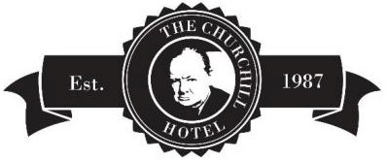

À La Carte Menu

Starters

Sourdough Board with Oil, Balsamic, and Olives £4.75
Locally Sourced Crusty Sourdough, Extra Virgin Olive Oil, Balsamic Vinegar, and Olives

French Onion Soup £6.95
Gruyere Croute

Yuzu Cured Salmon
Salmon Cured in Mirin, Yuzu and Soy, with Baby Radishes, Cucumber, £9.95
Apple, and Fried Rice Noodles

Moules
Steamed Mussels, Pancetta, Cider and Leek Jus £9.95

Camembert Filo Pastry Parcels
Spicy Plum Chutney, and Hazelnut Dressing £8.75

Heritage Tomato and Whipped Feta Tart £7.95
with Basil Pesto and Toasted Pine Nuts (ve)

Mushroom and Black Truffle Duxelles Tart (v) £7.75
Confit Egg Yolk, Mushroom Ketchup, and Crispy Onions

Mains

8oz Rump Steak £23.75
Vine Cherry Tomatoes, Field Mushroom, Fries, Watercress, and Peppercorn Sauce

Beef Brisket Wellington £19.95
Truffle Mash, Vichy Carrots, Buttered Kale, and Red Wine Gravy

Salt aged Spring Lamb Rump £22.95
Dripping Fondant Potato, Heritage Carrots, Baby Leeks and Salsa Verde

Citrus Cured Hake Loin £19.50
Parmentier Potatoes, Chargrilled Asparagus, Broad Beans, White Wine & Chive Cream Sauce

Pan Fried Sea Trout £20.50
Sweet Potato Rosti, Sun Dried Tomato, Sweet Pickled Red Onions & Salsa Verde Salad

Vegan Shepherd’s Pie £16.75
Chantenay Carrots and Kale

Sharing Platters

Charcuterie Meats Platter 12.95
Salami, Ham, Mortadella, Pastrami, Chorizo, Pepperoni, Pickles, Rocket Salad, Crisps, Olives, and Caper Berries. Served with Sourdough Bread.

Cheese Deli Platter £11.95
Black Bomber, Brie, Smoked Mozzarella, Cheddar, Harrogate Blue, Pickles, Rocket Salad, Crisps, Cherry Tomatoes, Olives, Caper Berries. Served with Sourdough Bread

Mixed Deli Board Platter £15.95
Salami, ham, pastrami, mortadella, chorizo, pepperoni Black Bomber, Brie, Smoked Mozzarella, Cheddar, Harrogate Blue, Pickles, Rocket Salad, Crisps, Cherry Tomatoes, Olives, Caper Berries. Served with Sourdough Bread

Sides

Skin On Triple Cooked Chips £4.50 Kale and Chantenay Carrots £5.50
Skin On Truffle and Parmesan Fries £5.50 Sourdough Bread £3.95
Salt and Vinegar Onion Rings £4.50 Mixed Salad £4.50

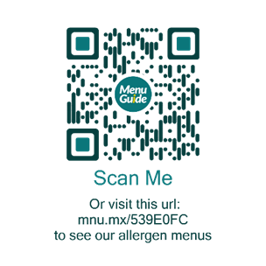

Desserts

Honey and Peach ‘Melba’ £7.75
Honey Cake, Raspberries, Honey Roast Peach, Crème Fraiche Chantilly, Blood Peach, and Raspberry Sorbet

Hot Chocolate Brownie £6.95
Hazelnut and Tonka Bean Ice Cream

Frozen Berries £6.95
Hot White Chocolate Ganache

Crème Brulee (ve) £6.95
Rhubarb Puree & Stem Ginger Shortbread

Boozy Affogato £8.95
Espresso, Kahlua, and Ice Cream

Lemon Meringue Tart £7.95
Set Lemon Curd, Meringue Tart, served with Berry Compote and Vanilla Ice Cream

Ice Creams and Sorbets £6.50

British and Continental Cheese Selection £10.95

Hot Drinks
Tea for One Green, Earl Grey, Chamomile, Fruit Flavours £3.25
Cafetiere for One £3.25
Cappuccino £3.45
Americano £2.75
Latte £3.95
Espresso £2.75
Hot Chocolate £4.95
Liqueur Coffee Irish, Brandy, Baileys, Amaretto £8.95

Please always inform your server of any intolerances or allergies.
You can view our allergen menus by scanning the QR code

We are committed to the Code of Best Practice on Service Charges, Tips, Gratuities and Cover Charges. We do not add a service charge to your bill. 100% of the tips you leave are distributed amongst the staff.

